Primary Boot
The Kria K26 SoM uses A/B boot concept, uses 2 image cointaining FSBL, PMU, ATF, U-Boot, if both are avaible then the Image Selector loads image A, if image A is not bootable (because we’re modifying it) then Image Selector loads image B and so on.
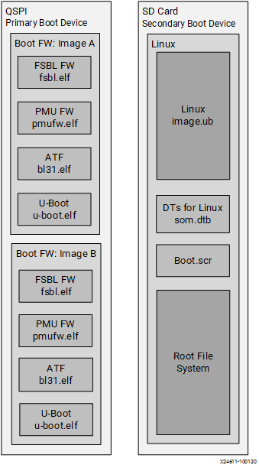
If both images are not bootlable (this doesn’t happen) then the Image Selector starts the Image Recovery.

Both Images are stored in the SoM QSPI memory, this is the map used for Kria SoMs:
Offset (hex) | Size (hex) | Sector Access | Description | Linux mtd
0x00000000 | 0x80000 | R | Image Selector Application | 0
0x00080000 | 0x80000 | R | Image Selector Application Golden | 1
0x00100000 | 0x20000 | R/W | Image Selector registers | 2
0x00120000 | 0x20000 | R/W | Image Selector register backup | 3
0x00140000 | 0xC0000 | - | Reserved | 4
0x00200000 | 0x300000 | R/W | Image A ( BOOT.BIN containing FSBL, PMU, ATF, U-Boot) | 5
0x00500000 | 0xA00000 | R/W | Space for larger images (PL - 8MB, RPU - 2MB) | 5
0x00F00000 | 0x80000 | R | ImgSel Image A Catch (ImgSel application) | 6
0x00F80000 | 0x300000 | R/W | Image B ( BOOT.BIN containing FSBL, PMU, ATF, U-Boot) | 7
0x01280000 | 0xA00000 | R/W | Space for larger images (PL - 8MB, RPU - 2MB) | 7
0x01C80000 | 0x80000 | R | ImgSel Image B Catch (ImgSel application) | 8
0x01D00000 | 0x100000 | - | reserved | 9
0x01E00000 | 0x200000 | R | Image Recovery Application | 10
0x02000000 | 0x200000 | R | Image Recovery Application backup | 11
0x02200000 | 0x20000 | R/W | U-Boot storage variables | 12
0x02220000 | 0x20000 | R/W | U-Boot storage variables backup | 13
0x02240000 | 0x40000 | R | QSPI Image Version Information* | 14
0x02280000 | 0x20000 | R/W | Secure OS storage | 15
0x022A0000 | 0x1d60000 | R/W | End Address (User) | 16

Fonti: https://xilinx.github.io/kria-apps-docs/bootfw/build/html/docs/bootfw_overview.html#primary-boot-device

0x00100000 | 0x20000

Image Selector Registers¶

Offset | Register | Description | Default Value for SOM Manufacturing Image
0x0 | Identification String | “ABUM” – A/B Update Mechanism | 0x4D554241
0x4 | Version | 0x1 | 0x00000001
0x8 | Length | 4 – No of registers present (not including the first 4) | 0x00000004
0xC | Checksum | SUM of all words excluding checksum | 0xAEB1BDB9
0x10 | Persistent State register | See table below | 0x01010000
0x14 | Image A offset | CSU multi-boot address offset of "Image A". Must correspond to 32 KB boundary. | 0x00200000
0x18 | Image B offset | CSU multi-boot address offset of "Image B". Must correspond to 32 KB boundary | 0x00F80000
0x1C | Recovery offset | CSU multi-boot address offset of "Recovery Image". Must correspond to 32 KB boundary. | 0x01E00000

0x00100010 | 0x4

Persistent Register¶

Bit width | Field | Type | Description
7:0 | Last Image Booted | R | 0 - Image A, 1 - Image B
15:8 | Requested Boot Image | RW | 0 - Image A, 1 - Image B
23:16 | Image B Bootable | RW | 0 - Not bootable, 1 - Bootable
31:24 | Image A Bootable | RW | 0 - Not bootable, 1 - Bootable

